Here is a map of Brampton School. Where do you think your class is? Do you recognise the field? What about the bicycle sheds?
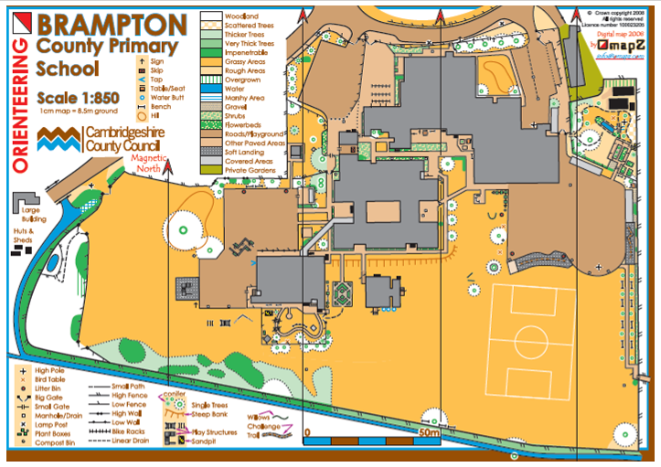
This is an arial view of the school. What would an arial view of your house look like? Could you draw a map of where you live? How would you show the different floors?
Will you use a key?

