**Remote Learning: Year 6**

**Monday 27th January 2025**

**Guided Reading:**

1. Listen to chapter 10 of Crater Lake
2. <https://www.youtube.com/watch?v=X5oNRp74Lws>
3. Summarise the chapter in 10 words exactly.

**Maths:**

**Similar Shapes**

1. Watch the video on White Rose about similar shapes and complete the questions as you stop the video.
2. <https://whiteroseeducation.com/parent-pupil-resources/maths/home-learning?year=year-6-new&term=spring>
3. Draw some of your own similar shapes in line with the objective.

**English:**

1. Look at the picture below and describe using POAMS. Make your description as vivid and powerful as possible or create your own dragon and draw and describe it.

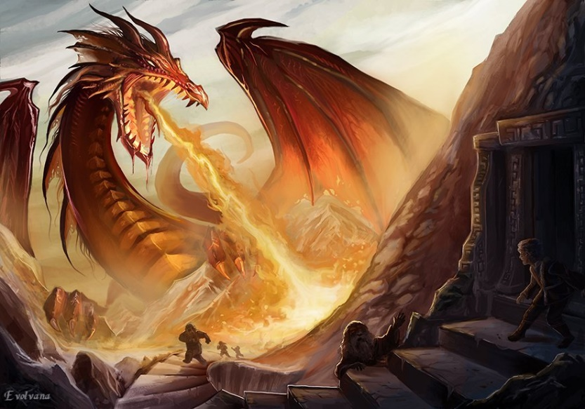

**This afternoon:**

We would like you all to complete your weekly homework and practise your times tables. Pay particular attention to your 7 times tables as this is the focus for your test this week.